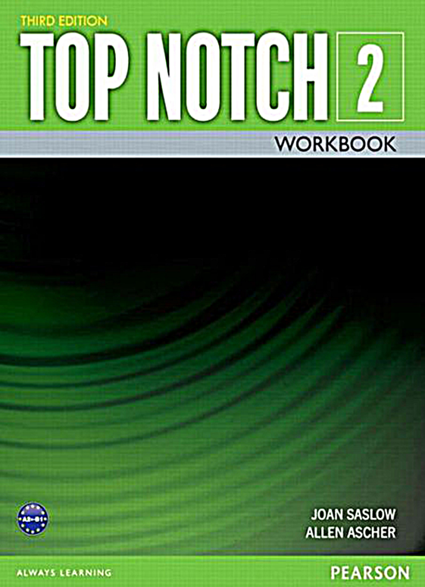

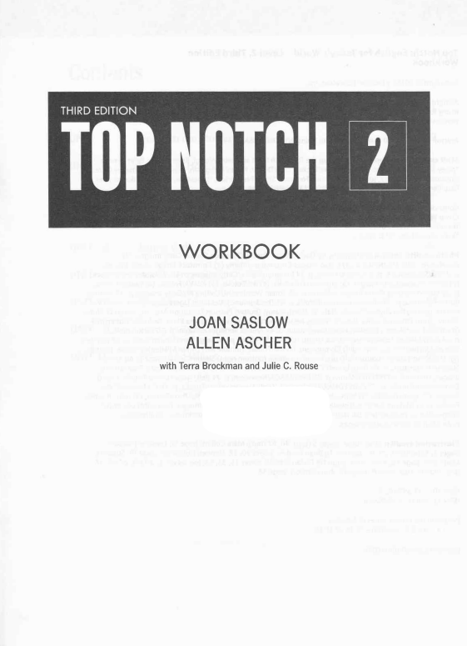

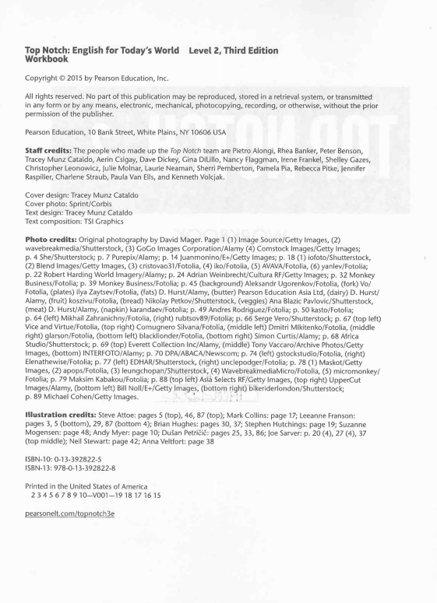

Contents

UNIT 1 UNIT 2 UNIT 3 UNIT 4 UNIT 5 UNIT 6 UNIT 7 UNIT 8 UNIT 9 UNIT 10

GettingAcquainted.... .......1 CoingtotheMovies .....9 Staying in Hotels . .17 Cars and Driving . .27 Personal CareandAppearance... ...30 EatingWell . .....48 AboutPersonality... ...58 TheArts ....04 Living in Cyberspace. . . .74 EthicsandValues.... ... 84 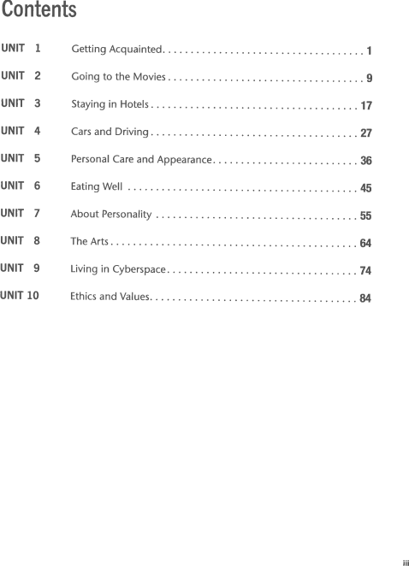



lIt

Getting Acquainted 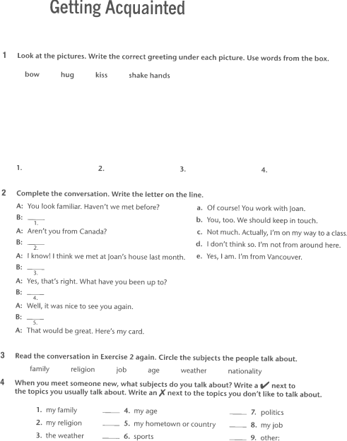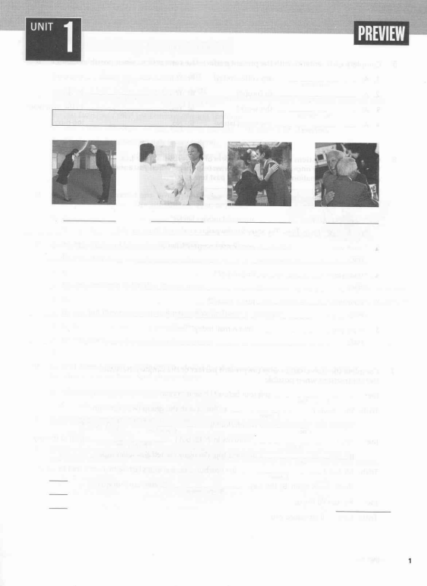

1 took at the pictures. Write the correct greeting under each picture. Use words from the box. bow hug kiss shake hands

2. 3. 4. 1. 2 Complete the conversation. Write the letter on the line.

A: You look familiar. Haven't we met before?

a.

B:-

b.

1.

A: Aren'tyou from Canada?

c.

B:-

d.

2.

Of course! You work with Joan.

You, too. We should keep in touch. Not much. Actually, l'm on my way to a class. I don't think so. l'm not from around here.

A: I know! I think we met at Joan's house last month. e. B:-

3.

A: Yes, that's right. What haveyou been up to? B:-

4.

A: Well, it was nice to see you again.

B:-

5.

A: That would be great. Here's my card.

Yes, I am. l'm from Vancouver.

3 Read the conversation in Exercise 2 again. Circle the subjects the people talk about. family religion job age weather nationality

4 When you meet someone new, what subjects do you talk about? Write a y' nextto the topics you usually talk about. Write an f next to the topics you don,t like to talk about.

1. myfamily _ 4. myage _ 7.

politics

2. my religion

5. my hometown or country

g.

my job

3. the weather

6. sports _ g. -

-

-

other:

Complete each sentence with the present perfect. Use contractions when possible.

B: Yes,

1. A:you | / have / have any coffee today?

two cups.

2. A:

to Europe?

B: Yes,

to Spain.

you / be we/be

3. A: 4. Az

you / exercise

this week?

any books lately?

B: Yes, B: No,

t/go

to the gym twice. too busy. 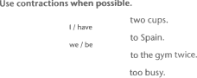

you / read l/be 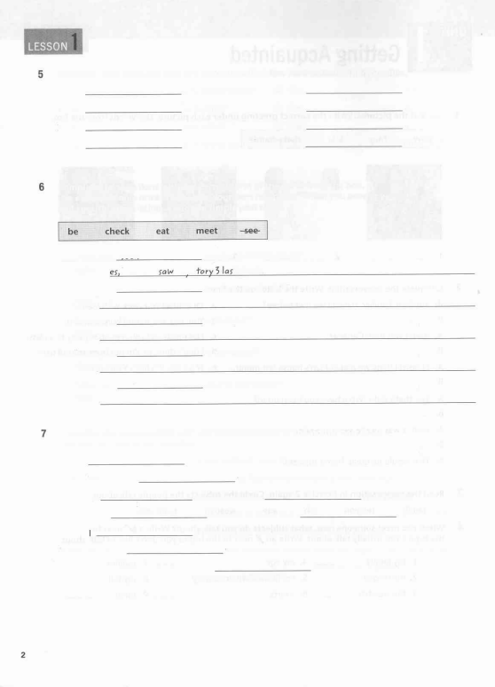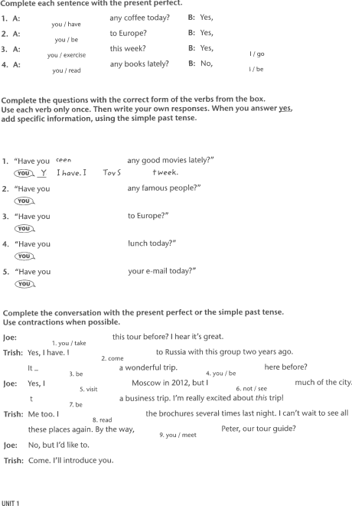

Complete the questions with the correct form of the verbs from the box. Use each verb only once. Then write your own responses. When you answer ygt add specific information, using the simple past tense.

1. "Have you <ee^ any good movies lately?"

@Y I have.l -fovS lweek.

2. "Have you any famous people?"

@

3. "Have you to Europe?"

@

4. "Have you lunch today?"

@

5. "Have you your e-mail today?"

@

Complete the conversation with the present perfect or the simple past tense. Use contractions when possible.

loe:

'1. you / take

this tour before? I hear it's great.

Trish:

, I have. I2. cometo Russia with this group two years ago.

Yes

It_

a wonderfultrip. here before?

3. be 4. you I be

foe: Yes, I5. visit

Moscow in 2012, but I6. not / seemuch of the city.

t

7.be

a business trip. l'm really excited about this trip!

Trish: Me too. I8. read these places again. By the way,

foe: No, but l'd like to.

Trish: Come. I'll introduce you. UNIT 1

the brochures several times last night. I can't wait to see all 9. you / meetPeter, our tour guide?

I Complete the sentences. Circle the correct words. 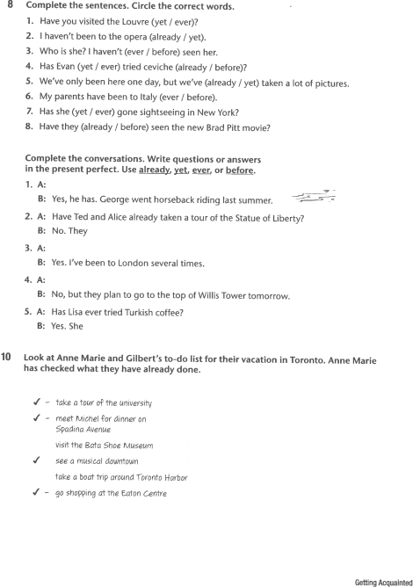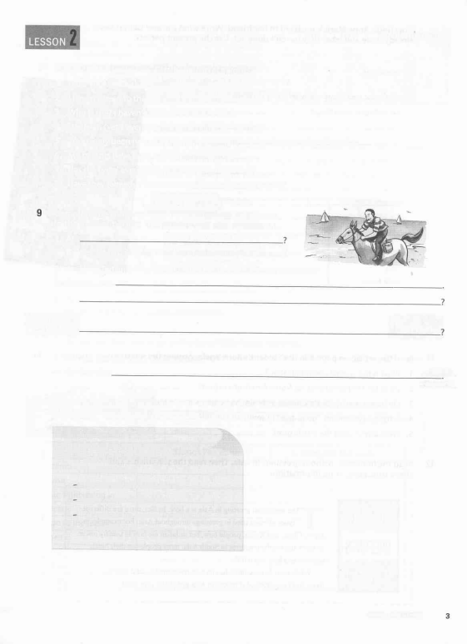

1. Have you visited the Louvre (yet / ever)?

2. I haven't been tothe opera (already lyet).

3. Who is she? I haven't (ever / before) seen her.

4. Has Evan (yet / ever) tried ceviche (already / before)?

5. we've only been here one day, but we've (already / yet) taken a lot of pictures. 6. My parents have been to ltaly (ever / before).

7. Has she (yet / ever) gone sightseeing in New york?

8. Have they (already / before) seen the new Brad pitt movie?

Complete the conversations. Write questions or answers

in the present perfect. Use already, yg!, ever, or before.

1. A:

B:

2. A: B:

3. A: B:

4. A: B:

5. A: B:

Yes, he has. George went horseback riding last summer.

Have Ted and Alice already taken a tour of the Statue of Liberty? No. They

Yes. l've been to London several times.

No, but they plan to go to the top of Willis Tower tomorrow. Has Lisa ever tried Turkish coffee?

Yes. She

10 Look at Anne Marie and Gilbert's to-do list for their vacation in Toronto. Anne Marie has checked what they have already done.

{- {-

./

lake afour ol Ihe universiltl

med Michelior dinner on 

Spadina Auenue

visit the Bata thoe Mttseum

see a mttsical downtown

Iake a boal I(ip around Toronlo ll arbor

{- go shopping al the t-aton CznIre

Getting Acquainted

11

flTRA READING OOMPREHENSION

Now finish Anne Marie's postcard to her friend. Write what dre and 6bert have already done and what they haven't done yet. Use the prcsent perfecL 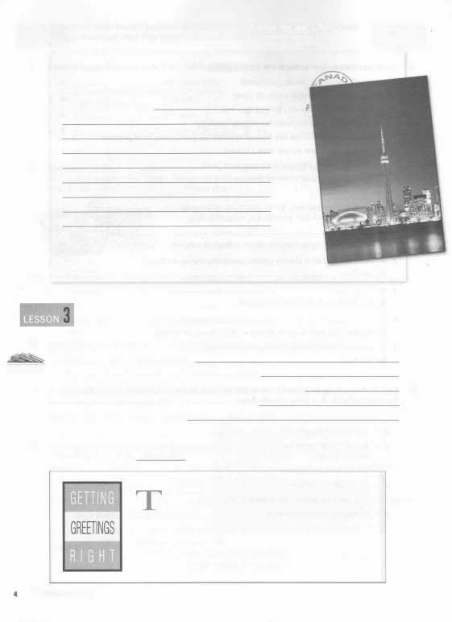

Dear Agnes, Sttnday, Augusf 6

Qilbert and I are hauing a wondertul time in Tororto.

We've done so man\Ihingsl

9eeyou when we gd back.

Love,

Anne Marie

Read the article on page 8 in the Student's Book again. Answer the questions. 1. What is non-verbal communication?

2. What kind of handshakes do North Americans expect?

3. On how many hands do Chinese indicate the numbers one to ten? 4. What gesture means "good-bye" in southern Europe?

5. What advice does the article give?

12 Read the information about greetings in Asia. Then read the statements and check true, false, or no information.

he traditional greeting in Asia is a bow. In fact, there are different

types of bows used in greetings throughoutAsia. For example, in

Japan, China, and Korea, people bow, but in Japan the bow is usually lower.

In India and nearby countries in South Asia, most people put their hands

together and bow just a little.

While each Asian culture has its own traditional special greeting, these

days, don't be surprised if people in Asia just shake your hand.

UNIT 1

1. People in China, Japan, and Korea bow when they

true false no information

!

n

n

greet someone.

2. ln Korea, people usually bow lower than in Japan.

!

n

n!

n

3. ln lndia, you shouldn't touch the person you are greeting.

tr

4. People in many places in South Asia use a similar greeting.

n

n

n

13 Complete the sentences about yourself.

1. ln this country, the most common greeting is

2. When I greet someone for the first time, I usually

3. When I greet a family member or close friend, I usually

History of the Handshake

Shaking hands was a way of making sure

that people were not carrying a weapon

such as a knife or sword. When you shook

hands, you were saying, "Look, I don't have

a weapon. ltrustyou. Let's be friends."

14 Complete the chart. Write things you've done and things you haven't done but would like to do. 

Things l've done Things l'd like to do

climb cl;mb l4t Kilimonjaro climto l\1. Everesl

Things l've done Things l'd like to do

climb

visit

go sightseeing in

learn

go to the top of

see

try

meet

take a tour of

Getting Acquainted

15 CFIA!-ilEh{GE. Look at your experiences in Exercise 14, Write aboutthree things you've done using already or before. Describe each experience with a participial adiective. 

1.

2.

3.

Now write about three things you haven't done but would like to do. Use ys!, have never' or haven't ever.

1.

2.

3.

Look at the answers. Write information questions, using the question words in parentheses. 1. A: (Where)

B: He's lived in Santiago, Budapest, and Kyoto.

2. A: (How)

B: lt's been great-sunny and warm every day!

3. A:

B

4A

B

5A

B

6A B

Sophie has studied English, Spanish, and Japanese.

(Which)

They've gone to the Metropolitan Museum of Art and the Museum of Modern Art. (How many)

She's been to Paris three times.

(Who)

l've met Mr. Russ, Mr. Sherman, and Ms. Savidge.

Rewrite each sentence, changing the placement of Ye! or already. 1. We've taken that tour already.

2. They haven't yet climbed Mt. McKinley.

3. Has he eaten dinner already?

4. l've already gone sightseeing in Prague.

5. She hasn't tried Vietnamese food yet.

UNIT 1

Complete the sentences. Circle the correct words. 1. Have you (yet / already) taken pictures of the City of Arts and Sciences building?

2. Josefina hasn't had her lunch (yet / already). 3. Ryan has finished college (yet / already). 4. Has Michelle (ever / before) been to Greece? 5. My parents have (ever / never) gone on a cruise. 6. I haven't (ever / never) studied ltalian.

7. Ruth has (ever / never) tried duck before. 8. Simone is from Paris, but she's never gone to the top of the Eiffel Tower (ever / before)!

City of Arts and Sciences-Valencia, Spain

Think of a frightening, a thrilling, a fascinating, and a disgusting experience. Write questions with eygf.

I 

frightening: llave you ever )umped out of an airplane? i ..-z-*&''*' .tp.--'" .s.4't,^"..*,-l /-$a*.@ -a8.4' e, -.,,.,e,-,e{8 ,- ^ -,-.-,.>A "2"-.,r ,_n - _. J

1.

2. 3. 4.

frightening: thrilling:

fascinating: disgusting:

Now write short answers to your questions.

1. 2.

3. 4.

cHAtLENGE. what are four things that you've never done? write sentences using the words in parentheses. 

l. (never)

2. (not ever)

3. (never, before)

4. (never, ever)

Getting Acquainted

A Read the run-on sentences. Write each sentence correctlyt SeparatetlE independent clauses with a period or combine them with a coordinating conjunction, such u and or but. 1. My parents went on a cruise to the Bahamas they haven't been to Bermuda yet. 

2. l've been to the top of the CN Tower, the view is amazing.

3. They went skiing in the Himalayas, the trip was thrilling'

4. l've tried snails before they were disgusting.

5. Devin has never traveled to continental Europe he has visited lreland before. 6. We have met before we were on the same sightseeing tour yesterday.

7. He's from Russia, he has studied English, he would like to learn Mandarin.

Look at Exercise C on page 11 in the Student's Book. On a separate sheet of paper, write your partner's experience. Describe what happened, where your partner was, who your partner was with, and how he or she felt.

After you write about your partner's experience in Exercise B, check to see if you have written any run-on sentences. Be sure to use a period to separate the independent clauses or use connecting words to combine them.

UNIT 1

Going to the Movies

1 Complete the sentences with words or expressions from the box. a bunch of Frankly I can't stand lt,s my treat I've heard

1. 2.

There are

good new comedies on Netclips. I can't decide which one to watch. the new Leonardo DiCaprio movie is fantastic. Have you seen it yet?

I have two tickets for the '10:00 show. Would you like to go? 3.

4.

The Wolf of Wall Street?

l'm too tired for a three-hour epic!

horror movies. I watch movies to relax-not to be frightened.

5.

2 Answer the questions about your own movie preferences. 

1. What actor or actress are you a big fan of?

2. What movie genres are you usually in the mood for?

3. What was the last movie you saw in a theater?

4. What was the last movie you watched at home?

complete the posting from an online movie message board. Use since orfor.

Back O roru,,arA Q neroao Stop l; H"r" rr search

l've been an action film fan L 20 years,

I was 10 years old. I haven,t seen a good one 2.

-_____ ._ a very long time. Last night I saw the movie ). Crazy Aliens, and it was terrible. I watched it for about an hour, but then I had to turn it off. I kept falling asleep!! tt was the worst action film l've seen _ 1997, when I saw Another Plonet Earth.lnrny opinfun, there still haven,t been any good action films Avatar in 2009. What a disappointment! s'



CHALTENGE. Which of the movies from the listing in Exercise 6 would you rather see? Explain your answer.

Look at Tom's favorite things and least favorite things. Then read each statement and check true or false, based on Tom's lists.

Tom' s Leasl Fav orrte -fllings

't. documentaries

z

t. 4. 5.

atrtp lo the mourftains classical music

gorng shopping

pasla

1. Tom would rather see a comedy than a documentary. 2. He'd rather take a trip to the mountains than to the beach. 3. He'd rather listen to classical music than pop music. 4. He'd rather go to the gym than go shopping. 5. Tom would rather eat rice than pasta.

true false nnn! nnn! nn

Look at the statements in Exercise 8. Write five true statements about your own preferences. Use would rather. 



Going to the Movies 11



11 Complete the conversation. Write the letter on the line.

A: Hi, Janelle. Seen any good movies recently?

a.

B:-

1.

b.

A: PIay Time? Whal kind of movie is that?

B:-

c.

2.

d.

A: Well, what is it about?

B:-

e.

3.

That doesn't sound very funny. Was it any good?

It was terrific. lt might be the funniest film l've seen this year.

It's a comedy.

Definitely. I highly recommend it. Yeah, I just saw Play Time at the Art Cinema.

It's about some high school kids who don't want to graduate.

It stars Wilson Grant-he was really hilarious. A: B:

4.

A: B: A: B:

The funniest? Wow!Who was in it?

5.

So you think I would like it? 6.

CI'IAILENGE" Write your own review about a movie you've seen. Use the reviews in Exercise lO for 

12

support. ln your review, answer the following questions: What kind of movie was it? Who was in it? What was it about? Was it funny? Romantic? Thought-provoking? Would you recommend it?

.../rt'"lf'4? r'.a: ">t?.s.r*!t.'a,\",a,.,.4 ,:r.tt.*t ',-t8 ,"'8f2'ts"'*- ..,."-,*, '"\,A,&,.

13 Read the article Con Violent Movies orTV Progroms Horm Chitdren? on page 22 in the Student,s Book again. Then read each statement and check true or false, according to the information in the article. qTRA REAI'IITG coilFREiiEilEiaiil true false

It's oK for children to watch violence in animated rV shows and movies. n !

1.

Children who watch a lot of fighting and killing on TV are more ! n

2.

likely to act violently as adults.

Eight is a safe age for children to start watching violent movies and TV shows. ! n

3.

Violence is normal, so children should be exposed to it. tr n

4.

children should learn that there are consequences for doing bad things. n n

5.

Parents should watch and discuss violent TV programs with their n n

6.

very young children.

Going to the Movies 13

11 Read the online blog post- Then anwthe questions 

How can I protect my kids from media violence? 

08 APR 2014 10:05 PM POST A COMMEiIT

The forecast is for rain all weekend, so I thought I'd rent some movies

for the kids to watch. When we looked at the movie list on the television,

my nine-year-old son clicked on the new release section. Every movie he

picked had a gun or an explosion in the picture. My six-year-old wanted a

movie based on one of his favorite toys. He begged me to rent it, "Please,

Dad. I have the toys. Why can't I see the movie?" But this movie is not

for children. According to the reviews l've read, it's very scary and pretty

bloody. We decided to rent a popular animated film I found in the family

section, but even that had fighting in it. And the violent scenes were also

silly and funny. Frankly, I think that's sending kids a bad message.

I was so upset that I decided to do some research on children and

media violence. Did you know that between the ages of four and eighteen,

the average child sees 200,000 acts of violence on W and other media

including 40,000 murders? Also, 60 to 90% of the most popular video

games have violent subject matter. Another study found that 61% of

television programs show some violence, and 43%o of these violent scenes

are used to make people laugh!

Why can't the entertainment industry make kids' movies and W shows

that are actually appropriate for kids? And when will they stop selling toys

based on violent movies and video games that young children should not

see or play? Maybe next time it rains, I'lltake my kids to the library instead!

1. What is James F.'s nine-year-old son interested in?

2. What does his six-year-old want to see?

3. What does James F. rent?

4. Why is he upset?

5. What does he think the entertainment industry should do?

6. Do you agree with James F.? Explain your answer.

15 Complete the statements, according to the blog post in Exercise 14. Circle the letter.

1. Between the ages of four and eighteen, the average child sees

on TV and in other media.

a. 40,000 television programs b. 200,000 murders c. 40,000 murders

2.

of all TV shows contain violent scenes. a. More than half b. Half -

-

c. Less than half

3. Violence on TV is often meant to be seen as

c. scary

a. unforgettable

14 UNIT 2

b. funny

-.

A Read the sentence in column A. Then decide if the sentence in column B is true or false.

A

1. She's been living in Milan for two years. 2. He's lived in Quito since 2011.

3. l've climbed Mt. Sorak.

4. How long have you been reading that book? 5. She's written a review of the new movie. 5. We've been waiting to see Grovity.

B true false

She still lives in Milan. n ! He doesn't live in Quito now. n ! lam climbing Mt. Sorak now. n n You are still reading the book. n n She's finished writing the review. n n We've already seen Gravity. n !

Think of three activities that you enjoy. When did you start? For each activity, write one present perfect sentence and one present perfect continuous sentence. Use for or since. 

c complete each statement with the present perfect continuous.

1. I really good things about the new Keira Knightley movie.

2. limmy 3. SkiTrip

9rve

me DVDs to watch on the weekends. terrible reviews.

get 4. Planet X make

5. Audrey's grandparents 6. Joe and Clem

7. We

look

travel

a lot of money since it came out last week. for her acting classes.

around Europe and Asia for nine months. for a movie for a half hour. .lust choose something!

Complete the sentences. Circle the correct words. 1. I (prefer / would rather) see a silly movie than a

5.

violent movie.

2. Annabelle (likes / would rather) classic films.

6.

3. We (prefer / would rather) to order tickets online. 4. She would (like / rather) to watch a romantic

7.

comedy.

Would you (prefer / rather) sit in the middle or on the aisle?

No soda for me. I (prefer / would rather) water.

Oscar (prefers / would rather) not go to the movies tonight.

Going to the Movies 15

Look at There is

1. A:

the answers. Write questions with like, prefe-r, or would rather. more than one correct answer.

A drama. l'm not that big on musicals. 

2.

Popcorn, please. I don't eat candy.

3.

Definitely a movie. Plays are fine, but I really love movies.

4.

Saturday works for me. l'm busy on Sunday'

5.

l'm not in the mood for Chinese food. What about Mexican?

6.

It doesn't matter to me. You choose.

Write a topic sentence for the following paragraph.

A

Topic sentence:

People don't imitate the behavior they see in movies. Would you try jumping from the roof of one tall building to another because you saw it in an action film? We live in a violent world. Just open any newspaper-or history book. What happens in real life is more violent than what happens in movies, and violence is not new. Violent entertainment has been around for a long time. Think about the gladiators in ancient Rome.

Why do some people think violence in movies is harmful? Why do others think it isn't? Complete the chart with people's opinions. Look at Exercise A above and the article on page 22 of the Student's Book for ideas.

Violence in movies

Harmful Not harmful

Can make children more aggregsive

On a separate sheet of paper, write two paragraphs of three to five sentences each with details about the following topics. Then write and add a topic sentence for each paragraph.

Paragraph 2

The worst movie you ever saw and why you

couldn't stand it.

16

Paragraph 1

The best movie you ever saw and why you liked it' UNIT 2



Which services are important to these hotel guests? Read what each person says and write the hotel service on the line. 

I like to work out for an

hour in the gym every

day before breakfast.

I have a very important

meeting in the morning.

I can't oversleep!

4.

I would rather swim

for exercise than lift

weights.

Put the conversation in order. Write the number on the line.

1 Can I speak with Kevin Mercer, please? He's staying in room 376.

That's right.

Yes. Could you tell him Barbara called? Please ask him to call me back at228-555-3'156.

-

One moment, please . . . I'm sorry. There's no answer. Can I take a message? Barba ra al 228-555-31 56?

ls that all?

-

7 Yes, that's it. Thank you very much.

-

18 UNIT 3

5 The fortune-teller is predicting the future. Read her predictions. Then rewrite the sentences dsing will. 

1.

2.

3.

4.

5.

Rewrite the following future statements and questions using will.

1. l'm going to call her later today.

2. She's going to stop at the front desk first.

3. My uncle is meeting my father at the airport,

4. What time does the tour group get back?

5. When are they going to make a reservation?

6. Where is your grandmother staying in Madrid?

Read the phone conversation. Then complete the

message sheet.

A: Hello. I'd like to speak with Ms. Marina Santiago, please. B: One moment, please. l'll ring Ms. Santiago's room . . . l'm sorry, but there's no answer. Would you like to call back later?

A No, l'd like to leave a message. please tell her that

To

oate $l!4 ri'" 3:i5 lfl$ WHILEYOUWERE OUT

Dur.l Dvts.l Dnars.

Phone

Number

tra

B

Anna Streed called. l'll be at 664-555-8723 until 5:OO today. OK, Ms. Anna Street. . .

E telephoned

fl returned your call

Extension

please call

will call back

No, it's Streed, S-T-R-E-E-D-that's "D,, as in ,,door.,,

A

OK, Ms. Streed. l'll make sure she gets the message. B

Message:

Staying in Hotels 19

I Look at the sentences in the box. Write the correct scnfnc bclwc.dt picture. 

l.

3. 4.

Write factual if the conditional sentence expresses a fact. Write future if it expresses a future result. 1. lf you check in early, you'll get the room you want.

2. lf a hotel room has wireless lnternet, guests don't have to go to a business center to check e-mail.

-

3. We will provide wake-up service in the morning if you request it.

-

4. lf you take something from the minibar, you'll have to pay extra.

-

-

10

20

Find the errors and write the correct sentences.

1. lf you will hurry, you'll catch the shuttle.

2. lf the fitness center is still open, I go swimming. 3. lf there will not be rental cars at the airport, will you take a bus? 4. lf I make my reservation early l'll get a cheaper room.

UNIT 3

Label the pictures. 

12 Look at the pictures. Then complete the conversations. 1. A: Guest services. May I help you?

B: Yes, please. Could you bring up some

A

I need clean ones. Certainly.

1.

And I could use a too. My hair is wet,

B

2.

and I don't see one in the bathroom.

A

Sure. We'll bring those up right away. Anything else? Oh, yes. I have a lot of dirty clothes. Could someone B

please

3

A

Yes, of course.

I think that's all. Thanks!

B

2. A:

B:

A:

B:

A:

B:

Front Desk. May I help you?

Yes, I'd like to go for a swim. ls the

No, l'm sorry, it closed at 9:00.

Oh. Well, maybe a workout. How about the No, it also just closed.

Oh, no. Well, I guess l'll have to do some work then. ls the still open?

still open?

A

B

21

No, l'm sorry, it closed at 6:30. Butyou do have high-speed lnternet access in your room.

Oh, OK. Thanks.

Staying in Hotels

13

EXTRA READIilG OOMPREHEl{SION

Read the website on page 34 of the Student's Book again. Then read the statements and check true, false, or no information.

true false

1. The Plaza is the most expensive hotel. n n 2. Broadway at Times Square Hotel is in the Theater District. n I 3. Yotel has suites. n n 4. Hotel Peninsula is a budget hotel. tr n 5. The Gershwin Hotel is several blocks away from n tr the Empire State Building.

6. The Hotel Newton is pet friendly. t] n

no information n

trnnn

n

14 Read the travel guide about places to stay in Dublin, lreland. STEEPING IN DUBLIN

€€€ History, Location 

Built in 1824, the Shelbourne is

the most famous hotel in Dublin

and a home-away-from-home for

generations of politicians, writers.

and actors. In fact, in1922 the Irish Constitution was written in Room

112! Overlooking Saint Stephen's

Green public park in the heart of

Dublin, the location is perfect for

sightseeing and shopping. Even if

you don't stay here, you must go for afternoon tea in the elegant Lord

Mayor's Lounge.

restaurant, room service, laundry service, business center, Internet service

€€€ Style, Nightffi

Ifyou're crazy abott style, the

Morgan Hotel is your place. With very modern d6cor and designer

furniture, this chic hotel is a

favorite of people who work in

fashion and music. The Morgan

is located in the trendy Temple

Bar district-an area popular

with young people and the center of nightlife in Dublin. Note: Can

be noisy at night.

restaurant, room service, laundry service, lJ;il*r center, Internet service, fitness

22 UNIT 3

€€ Atmosphere, Service A short train ride from the Dublin city center, in a neighborhood of beautiful old homes and gardens, the Aberdeen Lodge is the perfect place for a quiet and relaxing stay. The friendly staff welcomes guests with tea and cookies and is very helpful with tourist advice. Suites feature working fireplaces. Don't miss breakfast in the lovely dining room overlooking the garden. Note: There is no elevator. restaurant, room service, laundry service

€€ Convenience, Locqtion The Camden Court is a large hotel that offers business travelers a good night's sleep and lot of amenities at an affordable price. Rooms are small but clean and comfortable. A short walk from Saint Stephen's Green, the location is perfect close to tourist attractions,

restaurants, and shopping. The Camden Court is a good choice for business or pleasure.

pool. sauna. fitness room. room service. business center, free Internet service, beauty salon, restaurant, free parking

,l;

€ Price, Location

Experience student life-without the examsl-at this beautiful, historic university located in the center of Dublin. From June to September, visitors can reserve single and double rooms while students are away for the summer holiday. Rooms are large and clean, but don't expect many amenities or services. Not all rooms have their own bathrooms. cafeteria-style restaurant, free breakfast

15 Complete the chart. Use the travel guide in Exercise 14 to list an advantage and a disadvantage of each hotel. 

Hotel Advantage Disadvantage

The Shelbourne Hotel

The Morgan Hotel

The Aberdeen Lodge

The Camden Court

Trinity College

16 Read about the people's hotel needs and preferences. Use the travel guide in Exercise 14 to decide the best hotel for each person. Write statements with tf and will /won't.

Peter broke his leg, but we can't change

our flight. We need to be close to the sights

I'm traveling in the summer. Location is

importantto me, but l'm on a budget.

l'm attending a conference in Dublin. l'll have to

wake up early, so l'd like someplace quiet. Oh,

and l've got to be able to exercise.

Staying in Hotels 23

A Write sentences. Use have to, must not, don't have to, or doesn't have to. 1. Employees and guests / smoke in the hotel 

2. Hotel guests / check out before noon

3. A guest / use anything from the minibar

4. Housekeeping staff / make up the rooms

5. Hotel guests / reuse their towels, but they can

6. We / forget to unplug the iron

Read the situation. Write a suggestion. Use could, should, ought to, shouldn't, had better, or had better not.

1. The 7:OO show is sold out.

2. We have a lot of luggage.

3. lt's expensive to take a taxi to the airport.

4. The play starts at 8:00.

5. The Peninsula Hotel is very expensive.

6. We don't know where to go for dinner.

Write a rule for each place. Use be supposed to or not supposed to.

I . a hospita I Yov're nol Sup?oSed lo use your cell phone in a hos?ifal.

2. a restaurant:

3. a movie theater:

4. anairplane:

5. a museum:

6. the library:

Complete the conversation using will or won't.

Use contractions when possible.

A

1.

another night?

you be staying with us

B: No, we But I think we

be back next month.

3.

A: Creat. How

4.

you be paying today?

B:l use my credit card, if that's OK. 5.

A: Sure. That

24 UNIT 3

be fine.

Look at the pictures. What do you think the man is going to do? 

Write sentences with a form of be going to or not be going to.

1. 2. 3.

l'm sorry. Shet not

here right now.

Complete the conversations. Use the correct form of be going to if there is a plan for the future or will if there is not a plan.

1. A: Have you decided about your vacation yet?

B: Yes, we have. We to lndia!

l. go

A: Wow!When you

B: We out on the 20th. 3. fly

2. leave

A: That's fantastic. Where you

B: I don't know yet. I guess we should make hotel reservations-l;tfitrO"

just

5. findsomething when we arrive.

2. A: Guess what? I into a new apartment next week.

B: That you

6. move

's great news!

8. move

7. help

you if you like. What day

A

Thanks! lt

's this Saturday at 9 n.v. OK?

B

Oh, no! I

9. pick up

my sister at the airport then.

A

No problem. Just come by when you're free.

Staying in Hotels 25

Read the hotel reviews in Exercise 14 on page 22 again. Complete each statement with a reason, according to the information in the reviews. Write the letter on the line.

1. 2. 3. 4. 5.

I preferthe Shelbourne. . .

a.

l'm going to stay at the Morgan . . .

b.

-

l'd like to stay at the Aberdeen Lodge . . .

-

c.

l'd rather stay at the Camden Court . . .

-

d.

choseTrinity College. . .

-

because l'm notthat big on noisy cities'

since l'm looking for the cheaPest accommodations.

because l'm interested in lrish history. since I want to be in TemPle Bar.

-l

e. since l'm going to rent a car.

Rewrite the sentences in Exercise A, placing the dependent clause at the beginning of each sentence. Use a comma. 

1.

2.

3.

4.

5.

Look at the hotel reviews in Exercise 14. Which hotel would you rather stay at? Write the name of the hotel in the circle. List reasons with because or since in the boxes.

becaute

On a separate sheet of paper, write a paragraph about the hotel you chose in Exercise C. Explain why you would like to stay there. Give reasons, using becauie or since. Are there any disaivantages? After you write your paragraph, check carefully to make sure that there are no sentence fragments.

26 UNIT 3

Complete each sentence with a bad driving habit from the box. Use the -ing form of each verb.

speed tailgate talk on the phone text not signal

The car behind me is too close! I can see the driver's lipstick color. She's

1.

That person is laughing and . He's having a conversation while he's driving! 2.

That woman is turning right, but she's . That's so dangerousl 3.

The guy next to me has no hands on the wheel, and he's looking down! I know he's 4.

I

5. He's going 70 miles per hour near a schooll He's . l'm calling the police! 

Read the conversations. Complete the missing text in the speech bubbles with the expressions from the box.

Long time no see. Congratulations! I can't complain. catch up on old times

Let's have a <up of coffee and

We can meet at the coffee

27

Choose the correct response. Circle the lefter.

1. "This car was trying to park, and he hit another car. The driver was talking on the phone."

a. You've gotto be kidding! b. Justa moment. 2. "l don't think anyone was hurt in the accident." a. I can't complain. b. You're all set. 3. "So many people drive and text at the same time."

c. That's right.

c. Thank goodness for that.

a. Congratulations! 

4. "l just got a new car!"

a. Here you go.

Label the car parts.

28 UNIT 4

b. You can say that again. b. Congratulations!

l.

2.

3.

4.

8.

9.

lo.

c. Either way.

c. I can't complain. ord

Complete the conversation with the past continuous or the simple past tense.

A: Hi, Sandra. What's wrong?

B:l an accident on the way home today. i. have A: Oh, no! How it?2. happen

B: Well,l

3. drivehome when my sister She

4. call 5. ask

what I ,andl

6. do 7. tell

her I home and would see 8. 9o

her soon. But she

she had a funny

9. say

story that she just had to tell me. Anyway, by the end of the

story, I so hard I couldn't see-and 10. laugh

l- right into a stop sign.

11. drive

Choose the correct response. Write the letter on the line.

1. "l had an accident today." 2. "Ate you OK?"

-

3. "How did it happen?" -

a. The other driver was speeding.

b. Not really. The other driver will have to replace a taillight.

Thank goodness.

4. "Luckily, I was wearing my seat belt."

C.

-

d.

5. "Was there much damage?"

-

e.

-

Yes, l'm fine. No one was hurt. How awful.

CFIALLENGF. Have you or has someone you know ever had an accident? 

What happened? Write a note to a friend about it.

Cars and Driving 29

Look at the pictures. Write the letter of the correct picture after each phrasal verb.

1. fill up- 2. turn on -

3. drop off -

4. turn off -

5. pick up -

& " Complete the note below. Use the correct phrasal verb from Exercise 8. Sometimes you will need to use direct object pronouns.

l1i, Liso!

I made an appoinlmenllo have Slan lix lhe ear foday. Can you

1.

alfhe tervice slalion lhis aflernoon? f "ll Slan lhallhe lef ltvrn signal isn'l working. This morningl coulA2.,bvf now if's sfuck, anAI can't feem lo

. Askhimlo call mevthenthe caris done.I'll

4.

3.

o^ ny way home lrom work.

Love, Daniel

P.S - W hile yo v' re lhe re, co uld y o u lhe la nk? See you lo nighf! u 

10 Choose the correct response. Circle the letter.

'l. "l'm dropping off my rentalcar."

a. lt's all ready to go. b. Was everything OK? 

c.

2. "Any problems?"

a. I lust filled it up. b. The sunroof won't open.

c.

3. "What's wrong with the air conditioning?"

a. lt won't close. b. lt's out of gas.

c.

4. "ls the gas tank full?"

a. No. That's it. b. Oh, no! I forgot to fill it up.

c.

30 UNIT 4

Was there much damage? l'm sorry to hear that. It's making a funny sound. I wasn't paying attention.

11 Complete each sentence with a car type from the box.

a convertible a minivan an SUV a luxury car a compact car

1. Mavis loves hiking. She has with four-wheel drive that she can drive on rough roads when she takes a trip to the mountains.

lf you just need a car that's small and easy to park, would be great for you. 2.

3.

Mrs. Jeter drives every morning.

to take her husband to work and their five children to school

4. Peter thinks that owning is really cool. He said, "You can have the roof down and enjoy the sun, wind, and beautiful sky when the weather is nice." 

5. Jack is the president of a big company, and he drives with expensive leather seats.

12 Read the phone conversation. Then complete the rentalform.

Agent: Good afternoon. L & M Car Rental. How can I help you?

Renter: Hello. l'd like to make a reservation for June 1Oth.

Agent: Certainly. What type of car do you need?

Renter: A compact car.

Agent: Let's see . . . l'm afraid I don't have a compact available for that date. ls a full-size sedan OK? Renter: That's fine.

Agent: How long do you need the car for?

Renter: For eight days. Can I pick up the car here in Middletown and return it at Bradley Airport? Agent: Yes, that's fine. But there is a drop-off fee for one-way rentals.

Renter: All right. One last question. Where are you located?

Agent: We're at 355 South Street in Middletown.

L a M Car Rental Agency, Ltd.

Pick up date:

Pick up location:

Drop off date:

Drop off location:

Cars and Driving 31

Read Six Tips For Defensive Driving on page 46 of the Student's Book again. Then read the

13

statements and write D for defensive driving, A for aggressive driving, or I for inattentive driving.

EXTRA READING OOMPREHENSION

l.

2.

-

tailgating to make others go faster the "3-second rule"

5. 6.

-

slowing down in bad ,,.eather pulling overto avold a bad driver

3.

-following

multitasking while driving

7.

-

cutting other drivers off

4.

- -

checking your mirrors frequently

8.

- -

talking on the phone while driving

14 Read the article about renting a car in the U.S.

Driving in the U.S.A.

Planning a trip to the U.S.? Have you thought about how you'll get around? lf you're going to stay in a big city such as New York, Chicago, or San Francisco, public transportation is the most convenient option. However, to travel almost anywhere else in the U.S., you'll need a car. 

Car Rental Tips

Requirements: Most car rental agencies require drivers to be at least 25 years old. Some allow younger drivers, but may charge a higher rate. To rent a car in the U.S., you will need a credit card and driver's license. Visitors can usually rent a car and drive with a driver's license from their home country. However, if your license is in a language that doesn't use the Roman alphabet, you should obtain an lnternational Driving Permit in English.

Cost: Car rental rates change often, and you can usually save money by shopping around for the best price. Be sure to check travel and rental agency websites for special sales and discounts. Look for package deals that offer car rental and airfare or hotel for one low price. lf your schedule is flexible, compare prices for different travel dates. lt is often cheaper to rent a car on weekends or for a full week rather than a few days.

'" Yv:',.-.

Hidden charges: Always read the small print on your car rental agreement carefully-to check for hidden charges such as taxes, airport surcharges, and drop-off fees (an extra charge for returning a car to a different location from where you picked up). Make sure that you drop off the car with a full tank of gas. Rental agencies charge a fill-up fee and high gas prices if they have to fill up the gas tank. 

Safety: Before you leave the car rental lot, inspect the car carefully for damage and make sure everything is working properly. Ask the agent to note any problems on the rental form. Take a few minutes to become familiar with the car. Adjust your seat and mirrors. Locate the controls for the lights, turn signals, and windshield wipers. Then, buckle up! Wearyour seat belt, and ask your passengers to wear theirs, too. Most states have seat belt laws, and all states require that young children and babies sit in the back seat in special child seats. When you're ready, follow the traffic laws for the states you'll be driving in. lf you're not sure, check wlth car rental staff before you hit the road.

Find and circle the phrases in the article in Exercise 14. Then match the phrases and their meanings. Write the letter on the line.

1. 2. 3.

- -

get around

package deals hidden charges

a. extra costs that are not clearly stated b. fasten your seat belt

c. travel from place to place

4.

-

fee

d. begin a car trip

5.

-fill-up

buckle up

e. specials that offer two or more services for one price

6.

- -

hit the road

f. an extra charge for returnin g a car without a f ull tank of gas

32 UNIT 4

15 Answer the questions about renting a car in the U.S. Use information from the article in Exercise 14. Explain your answers. 

1. I am 23years old. Can I rent a car?

2. Do I need an lnternational Driving Permitto drive in the U.S.?

3. Where can I get the best price for a car rental?

I want to pick up a car in New York and drop it off at Los Angeles lnternational Airport. What hidden 4.

charges should I check for?

5. We are traveling with small children. Are there any special requirements?

A Complete each sentence in your l They were having dinner when

own way. Use the past continuous or the simple past tense.

, 2. While it started to rain.

3. While 4. When

Marie was watching TV, her husband

I was leaving my office.

5. He had an accident while

CHALLE 6K, Look at the pictures. On a separate sheet of paper, write a story about what happened using the words and phrases in the boxes.

drive

talk on cell phone not pay attention

run in front of

stop

Cars and Driving 33

C Put the words in order and write sentences. lf a sentence can be written in two ways, write it both ways. 

1. dropped / Margo / off / the car

Marao droopeA olf the car. OR lvlarao dropoedlhe cor of(.

2. up / it / Sam / picked

3. thetank/filled / I / up

4. can't I turn I on / Sue / the headlights

5. turn lotf llf can't/them

6. like / He'd I it I to / drop / off / at noon

7. llto /need luplitltill

8. picked / the car / William / up / has

D Label each underlined noun either common or proper. Then rewrite each sentence, replacing the underlined noun with a subject or object pronoun.

common 1. The car door is making a funny sound.

Il is making a f unnv sound

2. Mr. Lee rented the convertible.

3. The mechanic reolaced the taillioht.

4. Alex alreadv called Econo-Car.

5. The Amioo minivan hit the tree.

6. My sister will drop off the keys.

7. Mrs. Lane is going to pick up her son at 5:00.

34 UNIT 4

A lnsert commas where necessary in the following sentences. 

1. You need a driver's license and a credit card to rent a car.

2. The car rental charge included a drop-off fee a fill-up fee and an airport surcharge. 3. You should shop around for the best price and make a reservation.

4. Adjust your seat mirrors and the radio.

5. Locate the controls for the lights and turn signals.

B Combine each pair of sentences into one sentence consisting of two independent clauses. Use and. 1. The driver wasn't paying attention. He hit the car in front of him.

2. lt's raining. The sunroof won't close.

3. Lucy has five kids. She drives a minivan.

4. The GPS isn't working. We're lost.

Complete the statements. Look back at the article in Exercise 14 tor ideas. Add commas. 1. Many areas of the U.S. don't have good public transportation. Therefore

2. Car rental rates change frequently. Therefore

3. To find a good rate, check travel and car rental agency websites. ln addition

4. Return your rental car with a full tank of gas. lf you don't, you'll pay double the regular price for gas. ln addition

5. Most states have seat belt laws. Therefore

6. Small children must sit in the back seat. ln addition

On a separate sheet of paper, write about your driving or a friend or family member's driving. lnclude good and bad driving behaviors.

Cars and Driving 35

Personal Care and Appearance 

Complete the sentences with salon or fitness services.

1. Your fingernails look great. Did you get a

2. His hair was getting long, so he made an ap

3. I have a lot of tension in my shoulders from si

4. After my -

5. I love taking -(J- - classes. I feel so relaxed afterwards. Now unscramble the circled letters. What's the word?

2 Complete the conversation with questions from the box. Write the letter.

a. Do you think I could get a massage, too?

b. ls it customary to leave a tip?

c. How long will I have to wait?

d. Would it be possible to get a facial?

e. Can I charge it to my room?

Client:

I don't have an appointment. 1.

Receptionist: You're in luck. A client just canceled his appointment.

-?

Client: Great. z ?

Receptionist: Yes. But you might have to wait a bit. Client:

3.

-?

Receptionist: Let's see. I have something at 4:00.

Client: That's fine. 4.

Receptionist: Certainly. Just sign here, please. Then I'll show you to the dressing area.

-?

Client: I have one more question. -. ?

Receptionist: That's up to you. But most clients give about 10 percent.

36

3 How often do you get these salon services? Look at each picture and write a sentence. 

1.

2.

3.

4.

5.

4 Complete the word webs. Write personal care products on the lines.

Nail care

Hair care

Personal Care and Appearance

5 Complete the sentences. Circle the correct words. 

1. This store doesn't have (much / many) combs.

2. I can't find (some / any) sunscreen, but here's (some / any) body lotion. 3. Do you have (much / a lot of) razors at home?

4. She doesn't have (much / many) hair spray left.

5. Emma needs (some / any) dental floss.

6. Helen doesn't need (some / much) soap.

7. Do you have (any / many) deodorant?

8. I have (some / any) extra shampoo.

9. I found shaving cream, but there aren't (some I any) razors here. 10. Are you out of toothpaste? I have (some / much).

Complete each statement or question with someone,.[!9_(L!€., or anyone. ln some cases, more than one answer is correct.

1. made a ten o'clock appointment for a pedicure. 2. Excuse me. is at the front desk. Can

help me?

l'm sorry. We don't have available to help you now. 3.

There's ahead of you. Do you mind waiting? 4.

Did you see you know at the hair salon? 5.

6. waiting for a massage.

There's

Look at the pictures. Write statements using the words in parentheses and someone, no one, or anyone. ln some cases, more than one answer is correct.

l. (get / shave) There" tomeone gelting a thave.

2. (give lfacial)

3. (get / haircut)

4. (use / comb)

5. (give / massage)

6. (use / shampoo)

7. (get / manicure / pedicure)

8. (use / nailfile)

38 UNIT 5

8 Read the article Cosmetic surgery-for everyone? on page 56 of the Student's Book again. Then match the terms with their definitions.

.offifiEft$$ft 1.

chocoholic a. surgery to correct baldness

2.

-

liposuction

someone who likes chocolate very much and eats it all the time b.

3. 4. 5.

- - - -

hair restoration face-lift

chemical peel

surgery to remove wrinkles and other signs of aging from the face c.

treatment for wrinkles that removes the top layer of skin on the face d.

surgery to remove fat from the body

e.

Read the article about ways to improve personal appearance. 

Look Great - Without Cosmetic Surgery 2. Drink a lot of water, Get into the habit of drinking more

water. Well-hydrated skin is less likely to develop blemishes

or wrinkles. For clearer, smoother skin, try to drink at least

eight glasses of water a day. The more water you drink, the

better your skin will look. Also, drinking water throughout he 

day will curb your appetite-making it easier to eat less and

lose weight.

3. Exercise regularly, The physical benefits of exercise

include reduced body fat and more toned muscles. While

60 minutes of daily vigorous exercise is ideal, begin with a

oi it"

2

h ;a

Want to lose weight? Look younger? More and more people are turning to cosmetic surgery. While liposuction or a face-lift might sound like an easy way to get the results you want, it's important to remember that cosmetic surgery is, in fact, surgery. And surgery is not easy. lt's expensive, painful, and potentially dangerous. So, before you go under the knife, give these safe, low-cost ways to improve your appearance a try.

1, Get enough sleep. lt's called "beauty sleep" for a reason. Nighttime is when your skin and hair cells renew and repair themselves. Also, more blood flows to your skin when you're

sleeping, making it brighter. Most people know that lack of sleep can cause dark circles under your eyes. But many don't realize that not getting eight hours of sleep a night can also lead to wrinkles and weight gain.

reasonable goal-maybe 30 minutes three times a week. Choose something you enjoy, and enroll in a class, join a team, or make plans to work out regularly with a group of friends. 

4. Eat a healthy diet. To lose weight, you need to change your eating habits. You should choose foods that are low in fat and low in calories. You probably knew that already, but did you know that some foods can also improve the

appearance of your skin and hair? For beautiful skin, eat foods rich in antioxidants. Dark-colored fruits and

vegetables contain antioxidants, which help repair sun damage and prevent wrinkles. Bluebenies, spinach, and canots have a lot of antioxidants. For shiny, healthy hair, eat foods high in lean protein like fish, beans, and nuts. These foods may also help prevent hair loss.

What's good for your health is also good for your looks. So, get a good night's sleep and some exercise. Drink lots of water and eat fresh, naturalfoods-mostly fruits and

veggies. lt costs almost nothing and doesn't hurt, so what have you got to lose? Except maybe a few kilos!

Personal Care and Appearance 39

10 Complete the chart. Use information from the article. How mudr sleep, water, and exercise does the article recommend? What types of foods does it suggest? 



sleep

water

exerctse

diet

What are the results of doing what the article recommends?

11

12

40 UNIT 5

13 Think of a famous person or someone you know that represents both inner and outer beauty. Describe the person's inner qualities on the lines inside the head. Describe the person's physical features on the lines outside the head. 

Name of person:

14 Complete the statements with words from the box.

attractive health heart inner

kindness modest outer patient

Someone who is a good listener and lets others speak is

1.

2.

Beautiful skin and hair and a nice body are features of beauty. Coodness, to other people, truthfulness, and happiness with life are qualities

3.

of

beauty.

Someone who has nice physical features is

4.

The condition of a person's body is called

5.

Someone who doesn't talk proudly about his or her own appearance or abilities is 6.

7. "The best and most beautiful things in the world cannot be seen, nor touched . . . but are felt in the " -Helen Keller

Personal Care andAppearance 41

A Look in the medicine cabinet. Write sentences about the products you see, using words from the box. bar bottle can package tube

7

There are fourbollles ol nail polish. 1.

2.

3.

4.

5.

6.

Answer the questions about your own personal care products. Write complete sentences with some or anv. 

1. Do you have any dental f loss at home?

2. Do you need some toothpaste from the store?

3. ls there any shaving cream in your bathroom?

4. Are you wearing any perfume or aftershave now?

5. Do you have some sunscreen at home?

6. ls there any makeup in your bathroom?

7. Would you like some hand lotion?

42 UNIT 5

C Write a y' next to the sentences that are correct. 

1. E a. There isn't enough soap. 4. Z a. Does she have too many toothpaste? ! b. There isn't too many soap. fl b. Does she have enough toothpaste? 2. I a. Do you have too much razors? 5. E a. There isn't too much shampoo. E U. Oo you have too many razors? E U. There isn't too many shampoo.

3. n a. I don't have too many makeup.

n U. t don't have enough makeup.

D Complete each sentence with too much, too manv, or enouqh.

1. I couldn't wash my hair. There wasn't shampoo left.

2. I'm going to the store. Do you have flour to make the cake? 3. There are just people here. I don't feel like waiting.

4. Don't you think that's money for a pedicure? lt's too expensive. 5. You bought nailfiles. We only need one.

E Complete each sentence with fewer or less.

1. Bridget should wear makeup. She looks beautiful without it!

2. Budget hotels have amenities than expensive hotels.

3. This film has violence than that new action adventure movie.

4. The compact car will use gas than the SUV.

5. Which ticket line has people waiting in it?

6. The rental agency has cars with manual transmission than with

automatic transmission.

F Complete each sentence with something or anything.

1. We have new at our salon.

2. He didn't take for his headache.

3. Do you need from the drugstore?

4. I didn't see I like in the catalog.

5. lalways buy from that store.

6. I just can't relax. There is always to do.

7. They gave me to drink at the salon.

8. I don't know about cosmetic surgery.

Personal Care andAppearance 43

Read the paragraph. Find and correct five mistakes. 

Iwenllolhe supermarkellodaybecautel needeAlo gel nolhinglo cookfor -y Ai^ner parly fonighf.I wonled lo bvy tome Juice)too. [)ul whenl golfhere,lhere watn'l nolhing on the shelf!I we,tlo lhe slore manager and asked him why lhe shelves were emply. He apologized o,.td saiA lhere wae anylhing wro^g with lhe delivery fruck. "Il AiAn'l come f"Aoyi'hetold-e.HesaiAl'dhavelowailunlillhenexlday.NowlAon'lhavesomelhing

Think about a time when you had bad service at a place of business such as a salon, a car rental agency, a hotel, a movie theater, or a restaurant. Write an e-mail message to the manager complaining about the service. Describe the problem you had. Suggest a way for the business to improve.

Tot

Q"1.l-r+,

Prepare to turn your e-mail message into a formal business letter. Write the following information. 1. your address:

2. recipient's name and / or position and address:

3. 4. 5. 6.

today's date:

a salutation:

a complimentary close:

your signature and printed name:

Now type (or write) your formal business letter. Use the e-mail message you wrote in Exercise A as the body of your letter. lnclude all the information from Exercise B.

44 UNIT 5

Eating Well 

Look at the Healthy Diet Plate. Then read the statements. Check true orfalse. Vocabulary

true

1. You should eat 3 servings per day of carbohydrates. n 2. You should eat more vegetables than fruit. n 3. You should avoid breads and grains. n 4. Dairy products are a good source of fiber. n 5. You should eat fruit for carbohydrates. n 6. Exercise is an important part of a healthy life. n

Rewrite the false statements in Exercise I to make them true.

false nn

trn

trn

45

3 Complete the statements with phrases from the box.

l'd better pass I have no idea I'm watching my weight I have to admit I couldn't resist

l'm on a low-fat diet because

1.

The pasta looks delicious, but 2.

I usually avoid animal products, but

3.

dessert. I lust had to have it!

l'm on the Atkins diet.

the ice cream they served for

4.

want to enjoy it!

how much fat is in this cheeseburger-and I don't want to know. I just

Eating a low-fat, high-fiber diet hasn't been easy, but

5.

better as a result.

I look and feel

Look at the pictures. What do you think the people are saying? Write sentences about the people and their food passions. Use the words and phrases from the box. 

46 UNIT 6

Read about Kate's food passions. Then complete each sentence 

with used to or didn't use to and the verb.

When I was aktd,lloved flleets. lthink I ale abofitive 

@oktes a da1! Whenlwas aleenager,l sIafted eahng alol

ol meal. I had sleaks andlies almosf every dar,1. I didnt

caretor vegelables or+ut. Then on my 2D' bitthday,l

decidedl needed a cnange, so lbecame avegdaian.

The* dals I eal meal again, bul I avoidtallvtoods and

lrgx. l\telosl alol ol weigltt andlteel much bdler.

Kate

1. Kate a lot of sweets, but now she avoids sugar. 2. When she was a teenager, she fatty foods. 3. Before she turned 20, she vegetables.

4. She a vegetarian, but now she eats meat.

5. Kate care of herself, but now she eats well. take

6 Choose the correct response. Write the letter on the line.

1. 2. 3. 4. 5.

"Please help yourself."

"1'll pass on the chocolates."

-

"Don't you eat chicken?"

-

"1'm sorry. I didn't know you were on a diet."

-

"1'm a coffee addict. What about you?"

-

-

a. Actually, l've been cutting back. b. Thanks. Everything smells so good. c. lt's not a problem.

d. Don't you eat sweets?

e. Actually, no. lt's against my religion.

Complete the statements with a food or drink to describe your own food preferences. 'l . l'm notcrazy about

2. l'mavoiding

3. I don't care for

4. l'm not much of a drinker.

5. doesn't / don't agree with me.

Eating Well 47

Complete the conversation with phrases from the box.

is a vegetarian is on a diet is allergic to doesn't care for is avoiding

Let's have a dinner party Friday night. Help me prepare the menu. A

OK. Remember that my sister so we can't

B

make anything too fatty. Why don't you make some chicken?

A: I would, but Stella She never eats meat. Maybe I can make that rice dish.

B: I don't know. Miguel is trying to eat healthy, whole-grain foods, so he white rice these days.

OK . . . Then how about black bean soup with peppers?

A

Uh, I don't think Julio would like that. He

B

spicy food.

ls there anything that everyone can eat?

A:

Hmm . . . I don't know, but I hope you'll make that delicious chocolate cake for dessert! B:

I can't. Don't you remember how sick Paul was at our last dinner? He A:

chocolate!

l've got an idea-why don't we just go out to eat? Then everyone can order what they want! B:

Complete each negative yes / no question. 1. A1 Didn'f you go lo Lalvia last year? B: Yes, I did. I went to Latvia in August. 2. A: meat?

4. A: B:

5. A:

Yes, it was terrific.

a great play? more noodles?

No, I don't. I never touch meat.

B:

B

No, thanks. l'm full. l've had enough.

3A a doctor? China before? 

6. A:

B: No, she's not. David's mother is a dentist. B: Actually, no. But l've been to Korea.

Read the article "How Can lt Be?" on page 68 of the Student's Book again. Then complete the chart.

American eating habits French eating habits

consume rich foods, but stay thin

"clean their plates"

spend a long time at the table

drive to the supermarket

buy fresh food daily

48 UNIT 6

11 Answer the questions with information from the article on page 68 of the Student's Book. 1. How do the French see eating? How do Americans see eating?

2. Why do Americans "keep eating long after the French would have stopped,,?

3. What lifestyle change has affected French eating habits recently?

12 Read the online article about making lifestyle changes.

..,.,.,r:,,,,,t,,-,',;,;,.,,r.,.,tr.r,,,.,, r,,:,.-r,.,;.:::':l:]:-,:-'.,:,,. i@ E

HOw t0 male nealtnu lifestyle charues that last

lf you've ever

tried to change

the way you eat

or to lead a more

active lifestyle,

you know it isn't

easy. Making a

lifestyle change

is challenging

and it's especially

difficult to make

changes that

last. Often people

try to make many

big changes all

at once without

a clear idea of

how they will

accomplish their

goals. They

may struggle, get disappointed, and give up after a shod period of time. Here are some tips to help you make healthy changes that become lifelong habits:

[ruAfe one change at a time. Replacing unhealthy behaviors with healthy ones takes time. lf you try to change too much too fast, you won't be successful. Focus on one change you'd like to make. lf your goal is to improve your eating habits, choose one thing

to cut back on or add to your diet. Maybe resolve 

to stop drinking soda or eat some vegetables or

fruit with every meal. When a new healthy behavior becomes part of your normal daily routine, you can take on another change.

@ Start small. Changes are often easier to make if they are small. Don't expect yourself to go from lying on the sofa watching TV every night to spending an hour a night at the gym. lnstead, take "baby steps." For example, you could start by exercising twice a week for 30 minutes. Then, when you've done this successfully for a few weeks, try three times a week for 45 minutes.

p Uafe a realistic plan. When you decide to make a lifestyle change, you need to plan what you will do and when, where, how often, etc. lf more exercise is your goal, figure out how you will schedule it into your week and put it on your calendar. lf you want to eat healthier, write down meals and snacks for the week. Keep the foods you'll need on hand, and consult your plan before you eat. Make sure the plan , you create is achievable and that it works for yout lifestyle. For example, if you're a big meat eaier, a plan to eat only vegetables is not going to happenl Likewise, if you're not a morning person, don't plan daily workouts at 5:00 n.rvr.!

Eating Well 49

13 Complete the statements with words and phrases from the box.

"baby step" challenging habits realistic struggle successful

1. You want the changes you make to become without thinking.

which you do regularly

It's difficult to make lifestyle changes. You may but don't give up. 2.

lf you try to make many big changes all at once, you probably won't be

3.

lf you want to stop drinking coffee, you could start by drinking two cups every morning instead of 4.

three. This is a

5. When you plan to make a change, be work for your lifestyle.

Set goals you can accomplish and that

6. Trying to change the way you eat is It takes a lot of effort. 

14 Think about a lifestyle change you have tried to make. Was your change successful? On a separate sheet of paper, explain why or why not.

15 Complete the postcard with the correct form of taste, smell, or look.

Hi Reiko,

I'm having a qreqltimein Mawakechl

\eslerday I walked in the main square, and tt

like a scene trom a movie!

PeoVle in long, beartiful robes were evetqunere,

andlherewas so muchloodl I saw somelish

IttaI likelhekndwe nave

al home. Somewhere elseinlhe markd,

I couldnl seewnere,Iherewas aknd ol gnlled meal

that Ienftic. liound rl, but didnt know if I shouldtry it. tt

3.

\ou should come

Seeyou soon,

Junko

50 UNIT 6

kind aF s\ange, btt I bougltt 50me anwq. lt was deliciousl bolh spicy and ^ted. lt wasnt at all whal I expeded! here on your nert vacqllonl

16 Complete the word webs. Write ttrree examples of foods that match each adjective. 

17 Describe an unusual dish you have tried. Where and when did you eat it? What did it look, smell, and taste like? Would you recommend it to someone or not?

Eating Well 51

A Read the statements. Then write a sentence with use to or used to about a habitual action that is no longer true today. 

1. Since Charlie started going to the gym every day, he's lost so much weight. Charlie diA^'l ute lo go lo lhe gym e\tery Aay.

2. When he wasn't working, Scott made dinner every night. Now he doesn't have time. 3. Paul began getting up early every day when he had children.

4. As Cindy got older, her tastes changed. Now she actually likes vegetables. 5. I can't believe Judy doesn't eat meat anymore!

6. When Peter's doctor told him that he had better stop smoking, he quit. 7. After Pamela and Ed got married, they bought their first car.

Write a yes / no question for each response, using a form of used to. 1. A: inlhaloarlo{lhe ci

B: Yes, I did. I used to work in that part of the city a few years ago.

2. A:

52

B:

3. A: B:

4, A: B:

5. A: B:

6. A: B:

7. Az B:

UNIT 6

No, they didn't. People didn't use to read the news online. Yes, it did. Breakfast used to be free at the Windfield lnn. No, they didn't. Foods didn't use to have labels. Yes, I did. I used to live closer to work.

Yes, they did. Cars used to use a lot more gas. No, I didn't. My brother used to drive a van, but not me.

Complete the sentences with be used to, affirmative or negative. 1. Michelle has been on a low-fat, high-fiber diet for many years. She

fru its,

vegetables, and whole grains. She

rich food, such as steak and ice cream.

Karen just got a haircut. lt's very different from her old style. She

2.

look yet.

We rented a minivan, but at horne I drive a compact car. I

3.

big car.

her new

driving such a

4.

amenities.

budget hotels, so it's a treat to stay in this expensive hotel with so many

Jeff is crazy about action movies. He

5.

screen.

watching a lot of violence on the big

Complete the statements in your own way. 

1. The Browns just moved from Alaska to Hawaii. They can't get used

2. Rose recently moved from a small town to a big city. She's getting used to

3. Connor used to be a vegetarian. He still hasn't gotten used to

Write three sentences about things you did often when you were a child. Use would.

1.

2.

3.

E Complete the conversations. Complete the negative yes / ns questions and write short answers.

1. A: B:

2. A: B:

3. A:

B

4A

B:

5. A: B:

you have any vegetarian friends?

None of my friends are vegetarian.

you trying to lose weight?

l'm on a diet.

he like spicy food?

. He can't stand spicy food.

there sardines on that pizza?

. The pizza has sardines on it.

Sandra allergic to fish?

. She doen't have any problem eating fish.

Eating Well 53

Complete each conversation with a suggestion using Why don't or Why doesn't. '1. A: l'm too tired to cook dinner tonight.

B

go out to eat?

2. A: Mr. Lee's old van keeps breaking down.

B

buy a new car?

3. A: My mother thinks the hotel room will be too small. 

B: reserve a suite?

4. A: That documentary was really long and boring!

B: watch a comedy next time?

A Circle the best subordinating conjunction to complete each sentence.

1. lt's important to eat fruits and vegetables (because / unless / although) they are sources of vitamins and fiber.

2. You should avoid fatty foods and sweets (unless / even though / if) you're watching your weight. 3. OntheAtkinsDiet,youcaneatbutter(since/eventhough/unless)ithasalotoffat. 4. You'll love the new Argentinean steakhouse El Matador-(unless / if / because) you're a vegetarian. 5. (lf / Since / Though) Hannah doesn't care for fish or seafood, we didn't go out for sushi. 6. (Because / lf / Although) she's cutting back on sweets, Danielle had a piece of cake at the birthday party.

7. Kate is avoiding dairy products (even though / unless / because) they don't agree with her. 8. (Unless / lf / Since) he has to stay up late studying, Andrew doesn't drink coffee.

9. (Although I lt I Unless) children are taught to always "clean their plates," they may become overweight.

10. (Unless / Though / Because) it's difficult to change your habits, you can succeed by making one small change at a time.

B Think about your eating habits today and your eating habits when you were younger. Write six sentences: three about your eating habits now and three about how you used to eat. Use subordinating conjunctions.

1.

2.

3.

4.

5.

6.

C On a separate sheet of paper, write a paragraph about how your eating habits have changed. 54 UNIT 6

About Personality

Read each description. Then guess the color being described.

1. People associate this color with power, intelligence, and sometimes evil. lt's popular in fashion because it makes people look slimmer.

2. People associate this color with cleanliness and purity. lt's popular in decorating because it goes with everything.

This is one of the most appealing colors. The color of the ocean and the sky, people find it peaceful

3.

and calming. lt's a greatcolorfora bedroom. lt's nota good choicefora dining room-unlessyou're on a diet.

This color is associated with energy and excitement. lt makes your heart beat faster-and increases

4.

your appetite. lt's a popular color for fast cars and restaurants. ln China, it means good luck.

2 Read the Photo Story on page 75 of the Student's Book again. Match each phrase or statement with its meaning.

1. 2. 3.

- -

getting a little tired of to me it was

pulling your leg

a. in my opinion it was

b. That's true. I hadn't thought of that. c. I don't want to

4.

point.

d. looks good with allthings

5.

-

l'd hate to have to

e. bored with

6.

-Cood

f. not thinking correctly about this

7.

- - -

on the wrong track goes with everything

g. joking by saying something that isn't true

Write about your own color preferences. 

1. What's your favorite color? How does it make you feel?

2. What room in your home would you like to paint a different color? What color would you choose? Why?

3. Paint colors have names that describe specific shades-such as "tomato red" or "emerald green." Create a name for your favorite shade of your favorite color.

FACTOID: Men, women, and colors

Studies have found that women

prefer red over blue, but men prefer

blue over red.

55

Complete Lucia's letter. Use gerunds and infinitives. Remember to put the verbs in the correct tense. 

Hi Rebeeca, i i

Well,Ilinally -ade a change! Laslweekl saidlo myself ,"I - t. caa,: s:"rc took al ovr ii old kilchen walls one more Aay!" SoI -fhem! My ,oo^-afe Sara saiA ;

2. decide / rePaint

we should @ a planbef ore we Ao il. She even :

4. suggest ; take I

a monlh or lwo lo lhink abo' I il. She said we shovlA I

5. practice / paint i

firrf,butl already know hov,t lo painl.I don'f . - Anvwaytl t,

6. need / learn t t' t

z "otn,''rd / try new fhings' Finolly' " ,. .no*" I nt" - the kilchen t i cheerfvlcolor_brighlyellow!I,mnot9ure,bvl5araffilhenel,li

9. ""t *"t / tL. i

color.Infacf,I don'flhinkshe ! t)"lI hope she doe5,becavsel i 10. enjoy / paint t

the livinq room ^exf.I

11. plan / paint ' 12. would like / paint

red! t ,

Whal do yov lhink abovl fh, f? i 'I

Lucia i ..-x.,,.i..t,:, ",-..,., .",*Uf.'.*

5 Complete each sentence with a gerund or infinitive and an adjective from the box. -iflomafo

annoying boring depressing enioyable exciting relaxing

1. l've had the most stressful week at work! I need a massage this weekend. get

I find it so

2.

We It',s

don't want

going to be really

mt55

tonight's game. Our favorite I

team is in the championship.

3.

Mo SO

st kids hate

9o

shopping. They think it's not any fun and complain, "This is

4. I had to ask a classmate to please quit

tap

his pencil on the desk. I found it very

5. I don'tfeel likewatch the mood for a sad movie.

6. Max usually doesn't mind

56 UNIT 7

that film. I hear it's very

exerctseHe finds it pretty

. l'm not in

6 

Complete the conversation. Use the correct preposition with the verb or adjective, and a gerund.

A: You look a little blue. What's up?

B: Oh, nothing really. l'm just sick of workinq late every night. 1. sick / work

A: ls that all? You look really down.

B: I'm

2. bored / dothe same thing every day. And I also feel

3. sad / spend

too little time at home.

Have you overtime? ' 4. complained / work A

B No. l'm my boss angty.l had to

5. afraid / make 6. apologize / finish late. And now my boss is us more work. 7. talking / give

a report

A

B

About Personality 57

Wow! I see why you are feeling blue. Why don't you start looking for a new job? Maybe I should.

Suggest something to cheer the people up. Write comPlete sentences. 

I'm really tired of this job.

l've been working late

every night for a month!

I'm really upset that I don't

have enough money to go

on a trip abroad this year.

A rainy Monday

always puts me

in a bad mood.

l've been feeling blue lately. l'm just bored with life.

I

EXTR/I READING COMPREHENSIOI{

Read the article about personality on page 80 of the Student's Book again. Then answer the questions. 1. What are people with easygoing personalities like?

2. What type of personality is the opposite of easygoing?

3. Why is it difficult to settle the "nature-nurture controversy"?

4. Where do most experts believe our personalities come from?

5. Do you think nature or nurture is more important in forming personality? Explain your answer.

58 UNIT 7

10 Read the posts on an online message board. Rank the people from 1 to 5, with 1 being the most introverted and 5 being the most extroverted. 

Are you an introvert, an extrovert, or a little of both? write your own reply to the message board topic in Exercise 10.

File Edit Links Tools Help Chat

About Personality

12 Read the article about astrology. Then answer the questions,

ASTROLOGY-FINDING YOUR PERSONALITY IN THE STARS

Why do you act the way you do? What is the secret to your emotions? Where does r our personality come from? Is it nature or nurture? Genetics or the environment? Or could it be the sun and the stars?

Some people think that birth order influences personality, but many others belier e that the dav you were born on influences your personality. These people believe in astrology. They belier e that the sun and the stars influence human personality and events.

Astrology may be a wav to understand human personality. Or it may be a false science. But millions of people around the world read their astrological horoscope every day-just in case!

Aquarius lli 

Jan 20-Feb 18

r verY active

. cheerful

. can be a clown

Pisces I

Feb 19-Mar 20

. honest

. easily bored with jobs

o likes quiet time

A Aries\,r

ffi Mar21-Apr1e

. enjoys being alone

r hard to get to know

. keeps thoughts and emotions inside M T&|;:;"Y,,

Gemini I

May 21-Jun 21

. worries about things

. can be self-critical

. can be hard to know

Cancer @

Jun 22-Jul 22

r interested in travel

. enjoys being with other people r always behaves appropriately

Leo Q

Jul 23-Aug 22

. happy with lots of people . cheers people up

. crazy about nature

VirgoTlP

Aug 23-Sept 22

Libra ^

Sept 23-Oct 23

. conservative

. spends time with a few friends o has strong emotions

Scorpio lTL

Oct 24'Nov 21

. friendly

. sensitive to others' emotions . not easy to get to know

Sagittarius /

Nov 22-Dec 21

. creative

o likes everything in moderation o gets along with everyone

Capricorn ffi

Dec 22-Jan 19

. calm

. seeks peace o good listener

. keeps ideas inside

a

. likes to spend time alone

a

. enjoys reading

a

has a lot of friends interested in events loves excitement

1. What is the basic idea behind astrology?

2. Which of the zodiac signs describe more of an introvert? 3. Which signs describe more of an extrovert?

4. What zodiac sign are you?

you? Why or why not?

60 UNIT 7

Does the description for your sign describe

5. Compare the personality traits for your birth order with the personality traits for your zodiag sign. Are there any similarities? Which describes you better? 

A Complete each sentence with a gerund or an infinitive. Use verbs from the box. lf either a gerund or an infinitive is correct, write both forms.

cook do drink play ride study watch

1. Susan can't stand the dishes after dinner.

2. Michael loves the guitar.

3. Marianna hates for exams.

4. Joseph would like 5. Beth doesn't mind 6. Jim likes

his bike.

for her family.

TV.

7. My friend Jane avoids whole milk.

Unscramble the words and phrases to complete the conversations. Use a gerund or an infinitive.

1. A: John

B: I know.

2. A:

He / leave / hates / his friends /dinner llonightlll

B:

3. A: B:

4. A: B:

Fine by me.don't mind I go I I I out to eat buy / discussed I Have I yst) and Peter / a hor.rse

I You I I / see / di6n'1""0".a

Well,

at the last minute / I / decided / come

About Personality 61

Complete each sentence. Circle the letter.

1. I love

TV in the evening.

a. watch b. to watch c. watched -

2. I hurt my knee last month, so I quit a.lo9 b. to jog c. jogging

3.

too many sweets is bad for You. a. Eating b. Eat c. Eaten -

4. My favorite thing to do after work is a. read b. to reading c. to read -

magazines.

5. lf you get an early start, you'll have a better chance of a. finish b. finishing c. to finish

-

your work on time.

6. I don't mind

the window. lt's freezing in here!

a. closing b. close c. closed

7.

-

well is a hard thing to do.

a. Sing b. To sing c. To singing 

-opera

D Find and correct seven errors in the diary.

E Complete each sentence with an affirmative or negative gerund.

1. You should start every day if you want to lose weight. 2. Sue was worried about enough money to pay her bills. 3. When willyou finishworkon that project?

4. Avoid a cell phone while you're driving.

use

5. Stella and I have considered a new car. We just don't have the money. 6. I apologize forbuy

you that l'd be late. l'm sorry thatyou've waited so long.

7. Let's start anymore!

paint. l'm going to love T at that old wallpaper

8. Natalie has been working very long hours lately. She's depressed about time with her family.

spendmuch

9. I suggest

62 UNIT 7

eatfatty foods. You'll be healthier.

A Complete each sentence. Circle the letter. Be careful to use parallel structure. One item has two correct answers.

1. Robert has begun to exercise, eat a healthy diet, and

plenty of sleep.

a. getting b. to get c. get

2. Julia hates working long hours and

-

enough time with herfamiry.

a. not spending b. to not spend c. not spend

3. Virgos like to read and

-

time alone.

a. spending b. to spend c. spend

-

4. Although he has been seeing a psychologist, he continues to feel down, to avoid interaction with

others, and

all the time.

a. feeling tired b. to feel tired c. feel tired -

5. Enioying being alone, being hard to get to know, and an Aries.

-

and emotions inside are traits typical of

a. keeping thoughts b. to keep thoughts c. keep thoughts 6. Some typical behaviors of a middle child are to break rules, have a lot of friends, and

rebellious.

a. being

b. to be c. be

-

B Answer the questions sentences, using word

1. What are your likes?

about your own likes, dislikes, and personality. Answer in complete s and phrases from Unit 7. Be careful to use parallel structure.

2. What are your dislikes?

3. Which extrovert personality traits do you have? 4. Which introvert personality traits do you have?

What is your birth position in your family? 5.

Which traits for this position describe you? 6.

7. What is your zodiac sign? 

8. Which traits for this sign describe you?

On a separate sheet of paper, write at least two paragraphs about your personality. ln the first paragraph, tell something about yourself. In the second plragraph, discuss where you think your personality traits come from-nature, nurture, birth order, and / or astrology.

About Personality 63

Look at the paintings and read the conversation. Then read the statements and check true or false.

A Quiet Night by Charlotte Greene

Sophie: ls this painting by Charlotte Greene? I had no idea she had so much talent!

Gerald: She doesn't really look like the artistic type, does she?

Sophie: I guess you can't always judge a book

Gerald:

Sophie: Gerald:

Henryby Min Kyung Paek

Hey, this is an interesting piece. lt's by Min Kyung Paek. I love her work.

I think it's kind of depressing. You do? Maybe you're just feeling a little blue today.

Sophie: No, I mean it. I guess l'm just not 

really into all the dark colors.

Gerald: Well, to each his own, I guess.

true false trtr

TN

NITI trntrtr

64

by its cover. lt's really quite good.

What do you think?

Gerald: I find it a little weird, actually. lt makes me feel nervous.

Sophie: But that's what makes it interesting. ln my opinion, it's exciting.

1. Cerald is really into Charlotte Greene's painting. 2. Sophie likes Greene.

3. Gerald is a fan of Min Kyung Paek's art. 4. Sophie finds Paek's painting depressing. 5. Sophie prefers darker colors to brighter colors. 6. Sophie and Gerald like the same kind of art.

Write a plus (+) next to the statements that indicate that the person likes the art, and a minus (-) next to the statements that indicate that the person doesn't like it.

1. 2.

-l

had noidea hehadso muchtalent. 6. Her work is very impressive.

-l

guess l'm justnotreallyinto modern art.

3. 4. 5.

This abstract sculpture is fascinating.

-

lt's an unforgettable photograph.

-

I find it a little boring, actually.

-

-

7.

-

8.

-

lt's a little weird, but that's what makes it so interesting.

This is an unusual piece, but I don't find it appealing.

What do Sophie and Gerald think of the paintings on page 64? Complete the chart. 

Sophie's opinion

Gerald's opinion

( AtLffi 6€" Which painting in Exercise 1 do you prefer? Why?

Write a few sentences expressing your opinion.



5 Read each sentence and decide if it is in the active voice (A) or passive voice (p).

1. 2. 3. 4. 5.

Many people visit the Metropolitan Museum of Art in New york. -

The glass pyramid in front of the Louvre was finished in 19g9. A color poster of the painting was made available.

-

The museum catalog has been translated into many languages.

-

-

Akira Kurosawa directed the film Seven Somuroiin i954.

6.

-

vase was made in ancient Egypt.

7. 8.

-That -The

photograph was taken fifty years ago.

Matisse painted La Musique in 1910.

-

The Arts 65

6 Use the information in the chart to write two sentences, one in the active voice and one in the passive voice. Be sure to use the correct verb with the artwork.

1. Sfi// Life with Watermelon (painting)

2. Vines ond Olive Irees (painting)

3. The Raven and the First Men (wood figure)

4. Citizen Kone (film)

5. Woterfront Demonstrofion (photograph)

Pablo Picasco oainled tt;ll L;fe wifh lilafermelonin1116- 1. Active:

St;ll Life wifh llafermelon was painledbv Pablo Picasro in111G. 2.

Passive: Active:

3. 4.

Passive: Active: Passive: Active: Passive:

5. Active:

Passive:

Read a page from a tour guide about Paris. Complete the conversation. Make a recommendation to someone who is visiting Paris, using the information in the tour guide.

The Rodin Museum

There are many 

wonderful museums to

see while you are

visiting Paris. One

museum you should

be sure to visit is the

lovely Rodin Museum.

The Rodin Museum

houses over 6,600

sculptures. There is also

an impressive garden.

A large number of

sculptures are presented

in this setting, including Rodin's most famous

work, The Thinker.In addition to the

sculptures, take a look at the excellent drawing

collection. Many of Rodin's sketches are there.

66 UNIT 8

@ Be sure

in Paris.

B: Really? Why's that?

@ wel,

2

B: No kidding!

@ They atso

You'll

4.

B: Thanks for the recommendation.

8 Choose the correct response. Write the letter on the line.

1. 2.

"ls this vase handmade?" a. Clay. lt's handmade. "What do you think of this painting?" b. yes, it is.

-

3. 4.

5.

- - -

-

"Where was the figure made?"

"Do you know when this photograph was taken?"

"What's the bowl made of?"

c. lt says it was made in Bulgaria. d. Not much. l'm not crazy about the colors.

e. Around 1980, lthink.

Unscramble the words to write questions. 

1. were / Where / built / those / wood chairs

2. made of / are / those / bowls / What

3. Were / painted / those / wood figures / by hand

4. was / painted / When / that / mural

5. this / made in Thailand / gold jewelry / Was

6. are / What / these / used for / cloth bags

10 Look at the pictures. Write sentences to describe the objects. Use words from the box oryour own ideas.

Material clay cloth glass gold stone wood Adjective beautiful boring

impressive interestingcool depressing

practical terrificfantastic fascinating

weird wonderful

"1. The hal is maAe of clofh-It's fanfaslie.

2.

sombrero hat, Mexico bag, Spain

3.

4.

elephant figure, lndia

5.

balalaika guitar, Russia

6.

67

rocking chair, Canada

vase, France

The Arts

11 Read the article about how to develop artistic talent.

f'lo, you'd like to improve your artistic

\ ability, but you think you don't have any

I f natural talent? The truth is you don't

have to be born with talent to be a good

artist-and to enjoy making art. Artistic skill

can be learned.

Many people who try Painting get

frustrated and give up because they feel they

lack the "artistic gene." However, the real

problem is that they have just never been

trained to look at the world like an artist.

When non-artists look at the subject of a

People who claim they have no artistic

drawing, they see it with the left side of their brains. They immediately begin figuring out the meaning of what they see. An artist pays attention to what is actually being seen-the lines. Are they straight or curved? Dark or light? Where do they intersect? 

Want to learn to see like an artist? Try this exercise. Find a large photo of a face and try to draw it. lt's OK if your drawing looks bad. Then turn the photo upside down and try again. This time focus only on the relationships of the intersecting lines and shapes. Almost always, the upside-down drawing, when turned right side up, will be much better than the right-side-up version! How did this happen? By turning the photo upside down, the left side of your brain stopped looking at the photo as a face. lnstead, the right side of your brain took over and began seeing the photo in a new way.

68 UNIT 8

@

talent may actually have talent. But they may not be able to use it because they worry, "What will people think? Will I look silly? Will my piece be awful?" Young children rarely have these fears. They just enjoy the experience of creating something. To be successful at art, you will need to adopt the carefree attitude that you once had as a child. Don't worry about the results. Just relax and enjoy the experience of creating art.

Anyone can develop the necessary skills and understanding to create art. Those with natural talent are able to learn more quickly and easily, but even they will need training, practice, and hard work. So, stop making excuses and get started! Take art lessons, read books on art, and attend art exhibits. Expose yourself to a variety of techniques, kinds of art, and other artists. And think of becoming an artist as a lifetime journey. Stop worrying about making mistakes and enjoy the adventure!

Answer the questions, according to the article. Circle the letter. 

1. What is the main idea of paragraph 2?

a. Lacking the "artistic gene" is a real problem.

b. You should always draw faces upside down.

c. lt's important to learn to see like an artist.

d. Try to use the left side of your brain when you draw.

2. What is the main idea of paragraph 4?

a. Children are better artists than adults.

b. Fear of making mistakes prevents many adults from creating art.

c. Fear helps adults find their artistic talent.

d. Beginners' artwork is usually silly.

3. What is the main idea of paragraph 5?

a. Artists with natural talent don't have to work hard.

b. lt takes a very long time to become a good artist.

c. Artistic ability can be improved by attending art shows.

d. Anyone can make art with practice and hard work.

12 Read the quotations by famous artists. Find a paragraph in the article that presents an opinion similar to that expressed by each artist. Write the number of the paragraph on the line.

1. I ( fvery child is an artist' The problem

" ir'iJ* io remain an artist once we

grow uP'' u

-Pablo Picasso

2._

[$ I am doubtful of anY talent, so whatever I choose to be, will be accomPlished onlY bY long studY and work.ll

-fackson Pollock

3._ 66 Creation begins with vision. The

artist has to look at everything as

though seeing it for the first time.l !

-Henri Matisse

R-ead the third paragraph of the article again. Try the drawing exercise on a separate

13

sheet of paper. Then answer the questions.

1. Which drawing was easier?

2. Which drawing took more time?

3. Which drawing looks more like the photograph?

4. Did the exercise help you to see more like an artist? Explain.

The Arts 69

14 Complete the biography of Pablo Picasso using the passive voice. 

Pablo Ruiz Picasso began studying art with his father. Then from 1895 until 1904, he painted in Barcelona. During this time, he made his first trip to Paris, where n" ,'oo"r. by the artwork of Henri de Toulouse-Lautrec. ln Paris, Picasso 2. irft,ence by all the poverty he saw. He was sad and angty that so many people lived without enough food or clothing. He

painted many pictures of poor people to bring attention to their situation.

ln 1906, Picasso metthe artist Henri Matisse, who was to become his longtimefriend. Picasso _inMatisse,sstyle,buthedidnotimitateit'Theartistshereallyadmiredwere 3. interest Georges Braque and Joan Miro. Picasso ,. rur..u.'-* by Braque's and Mir6's work. Together the three artists started the movement known as Cubism.

One of Picasso's mostfamous artistic pieces is

Guernico. Picasso by the violence

5. move

of the Spanish Civil War. This prompted him to paint

the piece.

15 Read the biography again. Rewrite the five sentences in the passive voice, changing them to the active voice.

1.

2.

3.

4.

5.

16 € g-Lg ffi€. Write a short paragraph about your favorite kind of art and your favorite artist. Use some of the phrases from the box.

interested in fascinated by inspired by moved by influenced by

t:

,

t'

t

t

II

I

f

,.

I

t

- "a ^ '-. .i. 70 UNIT 8

A lf possible, rewrite the sentences, changing the active voice to the passive voice. lf a sentence cannot be changed to the passive voice, circle the verb and write intransitive on the line. 1. Leonardo da Vinci painted the Mona lrsa in the 16th century. 

2. Pablo Picasso died in 1973 at 91 years old.

3. Paul Klee used simple lines and strong colors in his many paintings.

4. The artist's later work seems quite dark and depressing.

5. A new exhibit of impressionist paintings arrives at the Philadelphia Museum of Art this summer. 6. Marc Jacobs will show his spring collection at New York Fashion Week.

7. ln Florence, we walked from The Uffizi Gallery to the Accademia Gallery to see Michelangelo's Dovid. Choose the best answer to complete each sentence. Circle the letter.

1. This vase

made in 1569.

a. ts b. has been c. was d. was being -

2. Today, coffee

grown in more than fifty countries worldwide.

a. has been b. will be c. was d. is -

3. Right now, business cards

exchanged at the meeting.

a. were b. were being c. are being d. have been

4. The art exhibition

-

attended by over 1,000 people so far.

a. was b. has been c. is going to be d. is being

5. We probably

-

invited to the wedding. lt's going to be very small.

a. won't be b. weren't being c. haven't been d. weren,t

-

Use the words to write sentences in the passive voice.

1. French / speak / in Quebec, Canada

2. The Taj Mahal / build / around '1631

3. A new art museum / open / nextyear

4. Many products / make / in China

5. "lmagine" / write / by John Lennon

6. Your DVD player / repair / now

7. The Mona Liso I see I by millions of people since it was painted

The Arts 71

Read the description of a museum. Find and correctfour more mistakes in the use of the passive voice. 

The Frick Collection

The mansion of Henry Clay Frickl'"#f#f in ,fll4at the corner of Fifth Avenue and East ZOth Street in New York City. lt was later open to the public. Several improvements have made over the years. Works of Manet, El Greco, Bernini, Degas, Vermeer, and many other artists found throughout the mansion. Some of the museum's large collection of art displayed at temporary exhibitions around the world.

Rewrite the sentences in the passive voice. Use a by phrase only if it is important or necessary to know who or what is performing the action.

1. People in Cuatemala carved this wood figure.

2. Artists hand-paint these plates in France.

3. Valentino is showing a lot of bright colors this season.

4. Stores everywhere are going to sell her jewelry'

5. Swiss companies still make the world's best watches.

6. Shakespeare wrote King Leor.

Rewrite the sentences in the passive voice in Exercise E as yesf-na questions. 1.

2.

3.

4.

5.

6.

72 UNIT 8

Read the paragraph. Underline the topic sentence. Circle the supporting details. Cross out the two sentences that don't belong. 

I have been to museums in countries all over the world, but my favorite painting is in a museum close to my home. I am a real f an of The Moster's Bedroom by Andrew Wyeth because

B Think about your favorite painting. Answer the questions.

1. What is the title of the painting?

2. Who is the artist?

3. Why do you like it?

Prepare to describe your favorite painting in a paragraph. Create a topic sentence and supporting details.

a. What is the most important thing you want to say about the painting?

b. Write five sentences to support your topic sentence.

1.

2.

3.

4.

5.

On a separate sheet of paper, write a paragraph describing your favorite painting. Feel free to change the order of your sentences or add more details if you think it would improve your writing.

TheArb

Living in Cyberspace 

Read the Photo Story on page 99 of the Student's Book again. Then answer the questions. 1. What computer problem does Amy have?

2. What solution does Dee suggest?

Read the instant message conversation.

Then answer the questions.

ron22: Hey, Deb. Are you there?

dpike: Hi, Ron. Just catching up

e-mail.

ron22: Am I interrupting you?

dpike: Not at all. What's up?

ron22: I just emailed you some

pictu res.

dpike: Creat! What of?

ron22: Photos of my tripll! dpike: Cool! Can't wait to see them.

ron22: lt'll just be a second . . . tunArAA

ooll::.!, Ron. Stiil there? t didn,t get the pix. 'i ii i,l:;"{,; ixt?"fl :5! : :,,i,, . says the files are too largel. oo"'I::yrfge you shoutd try sending them one at a tirie. r:122: you think that woutd work? dpike: tt usually does the tri.i. """ ron22: OK, l,lltry it.

B/ueAnAA

1. What computer problem does Ron have? 2. What solution does Deb suggest?

74

3 Which of the following computer problems have you experienced? n computer won't start E lost a file E printer won't print n computer is slowing down E got a computer virus n forgot a password n keyboard freezes E mouse doesn't work n can't attach a file 

CHALtENGE,. Have you ever asked someone for help with a computer problem? lf so, who did you ask? What solution did the person suggest?

Choose the correct response. Circle the letter.

1. "What are you doing here at this hour?"

a. Nothing happens. b. Running antivirus software. 2. "Am I interruptin g you?"

a. Of course. b. Right.

c. l've never had a problem before. c. Not at all.

3. "When I try to click on an icon, my computerfreezes and won't do anything."

a. lt couldn't hurt. b. Sometimes that does the trick. 4. "You think that would fix the problem?"

a. lt couldn't hurt. b. l'll just be a second.

c. Maybe you should try restarting. c. Sorry to hear that.

6 Use the icon prompts to complete the conversation. Write the word on the line. A: Could you take a look at this?

B: Sure. What's the problem?

A: Well, I clicked on the toolbar to

and now everything is gone!1.

g my document,

B: Don't worry. You probably accidentally clicked on the Just move your cursor over there and click on this icon to A: Oh . . . There it is! Thank you!

2.}{i.on.

Living in Cyberspace 75

7 Complete each sentence with a word from the box.

click on cut paste print save scroll down select toolbar

1. Oh, no! I just lost all the work l've done on this document because I forgot to the file. 2. You can't if the printer is not turned on.

3. To a word, move the cursor over the word and highlight it.

4. You don't have to type the entire paragraph again. Just copy and it where you need it.

5. I tried to

the icon but nothing happened. What did I do wrong?

6. The has a list of icons that provide a quick way to use computer commands. 7. To see more information on the product, to the bottom of the page. 8. Your article is great but a little too long. Could you a few paragraphs?

Match each action with the correct purpose. Write the letter on the line.

He enrolled in an electronics course because he . . . a. needed to buy a printer.

1.

went to the electronics store because she . . . b. needed to be more orqanized. 2.

3.

-

I bought speakers because I . . . c. wanted to learn how to repair computers.

-She

4. 5.

He turned on the television because he . . . d. wanted to listen to music on the computer.

-

She bought a smart phone because she . . . e. wanted to watch the news.

-

-

Rewrite the sentences in Exercise 8, using infinitives of purpose. 1. 

2.

3.

4.

5.

10 Put the conversation in order. Write the number on the line. 1- t was wondering if you could help me with something. Why don't you get an OptiMouse? I have one, and I really like it.

Well, l'm thinking about buying a new mouse, but l'm not sure which one to get.

-

Then how about the UltraClick? lt's nearly as easy to use as the OptiMouse, but it doesn't

-

cost quite as much.

-

Of course. What's up?

I like the OptiMouse, but it's a little expensive.

-

7 Sounds good. l'll have to check it out.

-

76 UNIT 9